Database Design and Implementaion Document
Project Title: Library Management System (LMS)
Project Type: Full-stack Web Development Capstone Project
Document Version: 1.0

Logical Database Diagram

- A member borrows one or more borrowings (a member can borrow multiple items).
- A member reserves zero or more reservations (a member can make multiple reservations).
- Every member is a user, but not every user is necessarily a member
- A book can be borrowed in one or more borrowings (a book can be borrowed multiple times over its lifetime).
- A book can be reserved in zero or more reservations (a book can have multiple reservations).
- A borrowing can generate zero or one fine (a borrowing may result in a fine, but not all borrowings have fines).

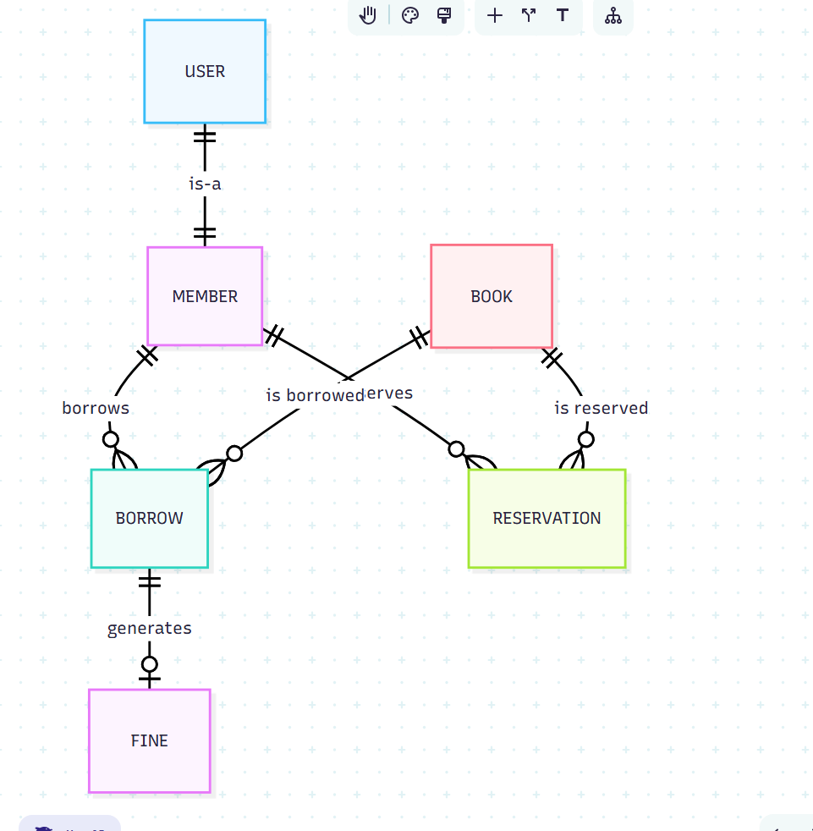

Entity-Relationship Diagram

Entity | Left Relation | Right Relationship | Entity
MEMBER | one-to-one | one-to-many | BORROW
MEMBER | one-to-one | zero-many | RESERVATION
USER | one-to-one | zero-to-one | MEMBER
BOOK | one-to-one | zero-to-many | BORROW
BOOK | one-to-one | zero-to-many | RESERVATION
BORROW | one-to-one | Zero-to-one | FINE

User
Field | Data type | Key | Contraint
id | int | PK
email | string |  | Unique
password_hash | string
full_name | string
phone | phone |  | /[1-9][0-9]*/
address | string
role | string |  | [Admin, Member]

Member
Field | Data type | Key | Contraint
user_id | int | PK, FK
member_id | string |  | Unique
join_date | date
status | status |  | [Active, Suspended, Expired]

Book
Field | Data type | Key | Contraint
id | int | PK
isbn | string |  | Unique
title | string
author | string
category | string
publication_year | date (year)
publisher | string
total_copies | int
available_copies | int |  | <= total_copies

Borrow
Field | Data type | Key | Contraint
id | int | PK
user_id | int | FK
book_id | int | FK
borrow_date | datetime
due_date | datetime |  | borrow_date + 14 days
return_date | datetime |  | >= borrow_date
times_renewed | int |  | <= 2 (default 0)
fine_amount | decimal |  | <= 20.00
is_returned | bool

Reservation
Field | Data type | Key | Contraint
id | int | PK
user_id | int | FK
book_id | int | FK
reservation_date | datetime
expiry_date | datetime |  | reservation_date + 14 days
is_fulflled | bool

Fine
Field | Data type | Key | Contraint
id | int | PK
borrow_id | int | FK
amount | decimal |  | <= 20.00
is_paid | bool
paid_at | datetime

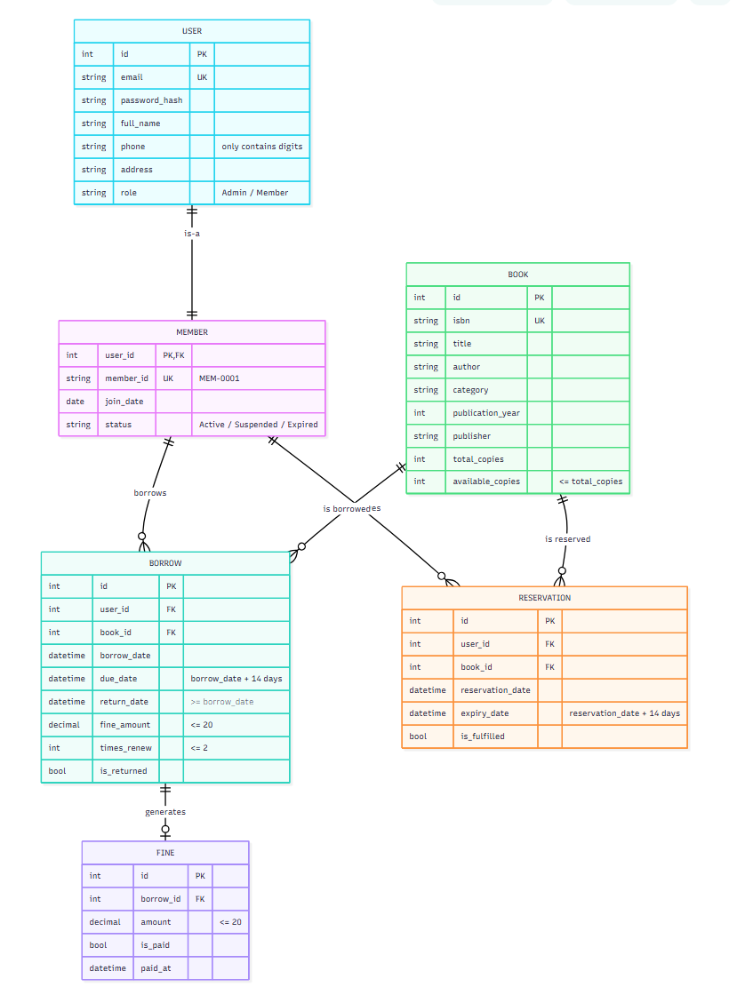

MySQL Statement
CREATE TABLE USER (
id INT PRIMARY KEY AUTO_INCREMENT,
email VARCHAR(255) UNIQUE NOT NULL,
password_hash VARCHAR(255) NOT NULL,
full_name VARCHAR(255) NOT NULL,
phone VARCHAR(20) NOT NULL,
address TEXT,
role ENUM('Admin', 'Member') DEFAULT 'Member' NOT NULL,

-- Phone: must contain only digits AND cannot start with 0
CONSTRAINT CHK_phone_digits_only
CHECK (phone REGEXP '^[0-9]+$'),
CONSTRAINT CHK_phone_no_leading_zero
CHECK (phone NOT LIKE '0%')
);

CREATE TABLE MEMBER (
user_id INT PRIMARY KEY,
member_id VARCHAR(20) UNIQUE NOT NULL,
join_date DATE DEFAULT (CURRENT_DATE) NOT NULL,
status ENUM('Active', 'Suspended', 'Expired') DEFAULT 'Active' NOT NULL,

CONSTRAINT FK_MEMBER_USER
FOREIGN KEY (user_id) REFERENCES USER(id)
ON DELETE CASCADE ON UPDATE CASCADE
);

CREATE TABLE BOOK (
id INT PRIMARY KEY AUTO_INCREMENT,
isbn VARCHAR(13) UNIQUE NOT NULL,
title VARCHAR(500) NOT NULL,
author VARCHAR(255) NOT NULL,
category VARCHAR(100),
publication_year YEAR NOT NULL, -- Proper YEAR data type (0000–9999)
publisher VARCHAR(255),
total_copies INT NOT NULL CHECK (total_copies >= 0),
available_copies INT NOT NULL CHECK (available_copies >= 0),

CONSTRAINT CHK_available_copies
CHECK (available_copies <= total_copies)

);

CREATE TABLE BORROW (
id INT PRIMARY KEY AUTO_INCREMENT,
user_id INT NOT NULL,
book_id INT NOT NULL,
borrow_date DATETIME DEFAULT CURRENT_TIMESTAMP NOT NULL,
due_date DATETIME NOT NULL,
return_date DATETIME NULL,
fine_amount DECIMAL(6,2) DEFAULT 0.00 CHECK (fine_amount <= 20.00),
fine_paid_at DATETIME NULL,
times_renew TINYINT DEFAULT 0 CHECK (times_renew <= 2),
is_returned BOOLEAN NULL DEFAULT FALSE,

CONSTRAINT FK_BORROW_MEMBER
FOREIGN KEY (user_id) REFERENCES MEMBER(user_id)
ON DELETE RESTRICT ON UPDATE CASCADE,
CONSTRAINT FK_BORROW_BOOK
FOREIGN KEY (book_id) REFERENCES BOOK(id)
ON DELETE RESTRICT ON UPDATE CASCADE,
CONSTRAINT CHK_return_date
CHECK (return_date IS NULL OR return_date >= borrow_date),
CONSTRAINT UQ_USER_BOOK_ACTIVE
UNIQUE (user_id, book_id, is_returned)
);

CREATE TABLE RESERVATION (
id INT PRIMARY KEY AUTO_INCREMENT,
user_id INT NOT NULL,
book_id INT NOT NULL,
reservation_date DATETIME DEFAULT CURRENT_TIMESTAMP NOT NULL,
expiry_date DATETIME NOT NULL,
is_fulfilled BOOLEAN DEFAULT FALSE NOT NULL,

CONSTRAINT FK_RESERVE_MEMBER
FOREIGN KEY (user_id) REFERENCES MEMBER(user_id)
ON DELETE CASCADE ON UPDATE CASCADE,
CONSTRAINT FK_RESERVE_BOOK
FOREIGN KEY (book_id) REFERENCES BOOK(id)
ON DELETE CASCADE ON UPDATE CASCADE,
CONSTRAINT UQ_ACTIVE_RESERVATION
UNIQUE (user_id, book_id, is_fulfilled)
);

CREATE TABLE FINE (
id INT PRIMARY KEY AUTO_INCREMENT,
borrow_id INT NOT NULL,
amount DECIMAL(6,2) NOT NULL CHECK (amount <= 20.00),
is_paid BOOLEAN DEFAULT FALSE NOT NULL,
paid_at DATETIME NULL,

CONSTRAINT FK_FINE_BORROW
FOREIGN KEY (borrow_id) REFERENCES BORROW(id)
ON DELETE CASCADE ON UPDATE CASCADE,
CONSTRAINT CHK_paid_at
CHECK (is_paid = FALSE OR paid_at IS NOT NULL)
);

-- Indexes
CREATE INDEX IDX_BOOK_TITLE ON BOOK(title);
CREATE INDEX IDX_BOOK_ISBN ON BOOK(isbn);
CREATE INDEX IDX_BORROW_DATES ON BORROW(borrow_date, due_date);

